**Day 4 - Dynamic Frontend Components – ShopCo**

**Displaying Data from Sanity**

* The data is successfully retrieved from Sanity and displayed on the designated page.

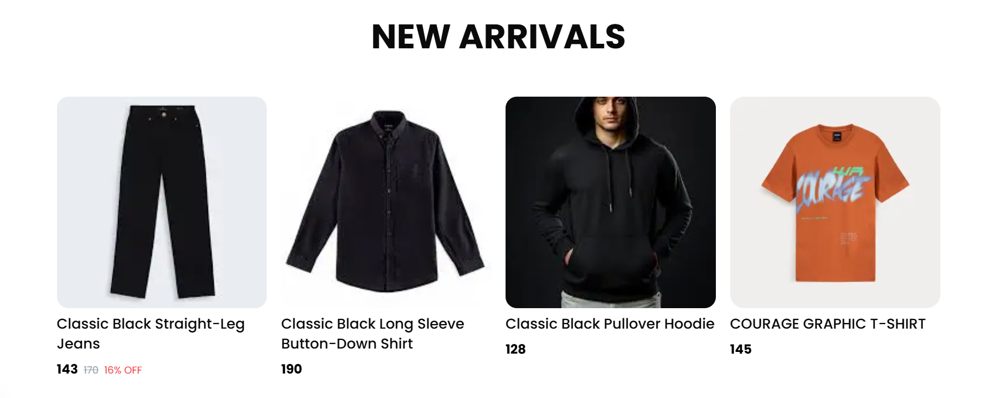

**Dynamic Product Page**

* **Dynamic product page code**

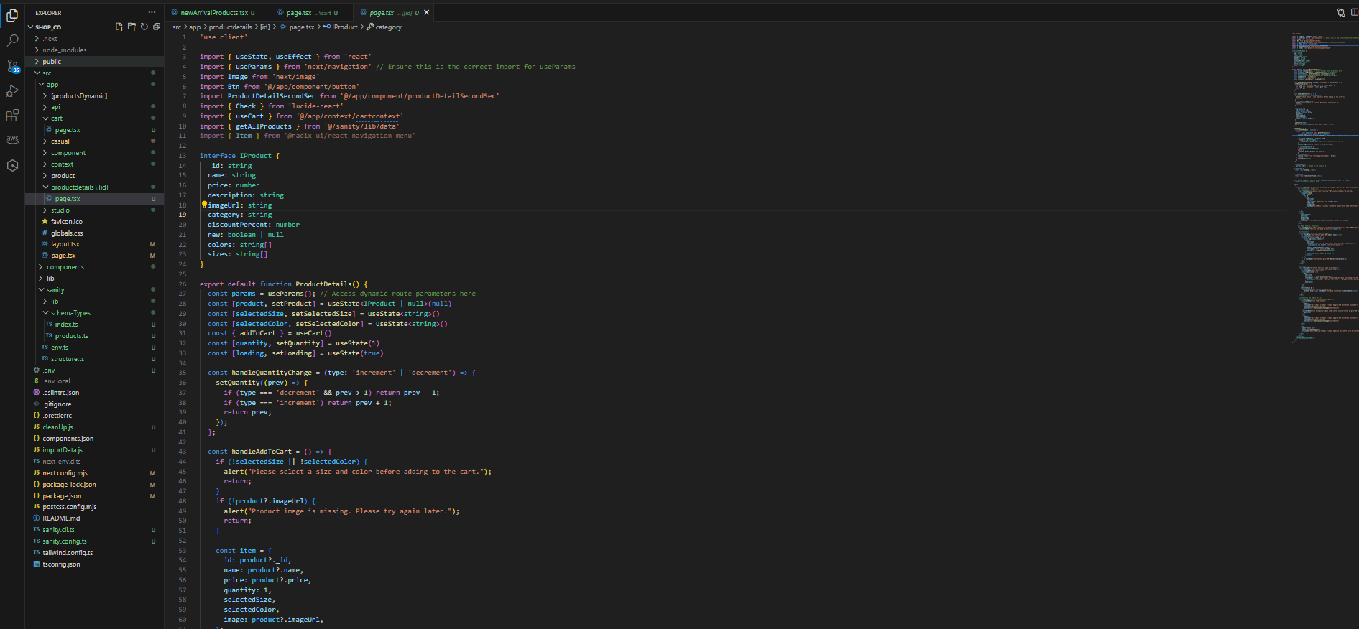

* **A dynamic product page has been implemented to allow users to:**
  + **Select product size and color.**
  + **Add the product to the cart by clicking the "Add to Cart" button.**

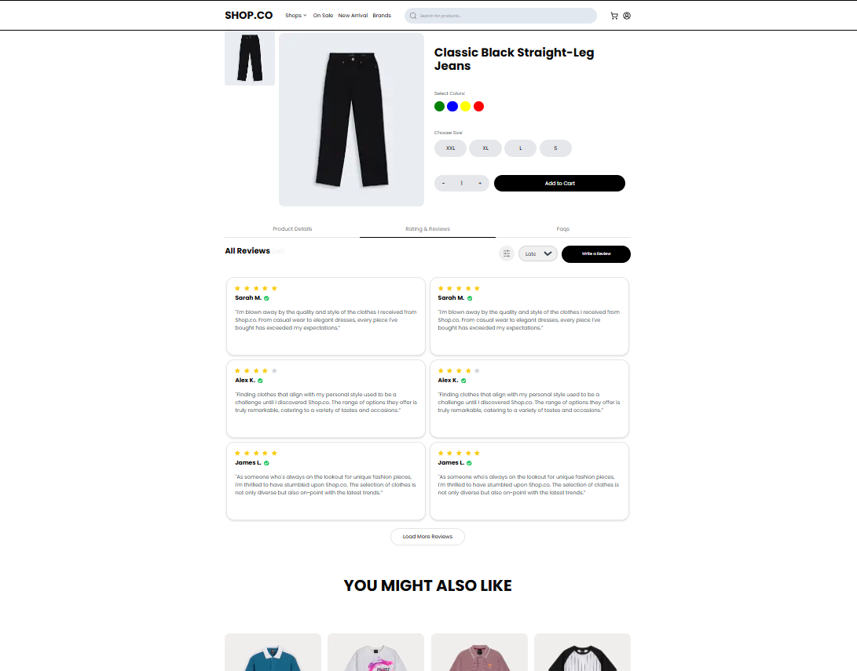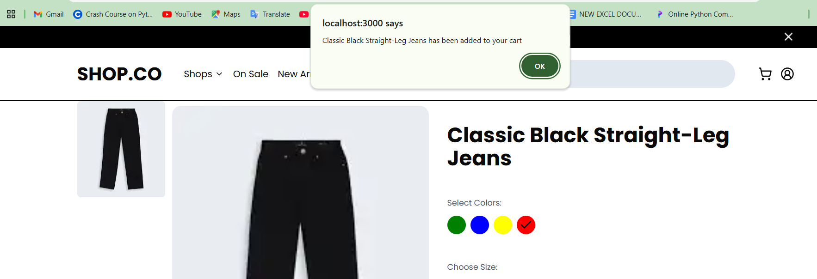

**Cart Functionality**

* **After adding a product:**
  + **The selected product is successfully added to the cart.**
  + **The cart page displays all added products, along with their details such as size, color, and quantity.**

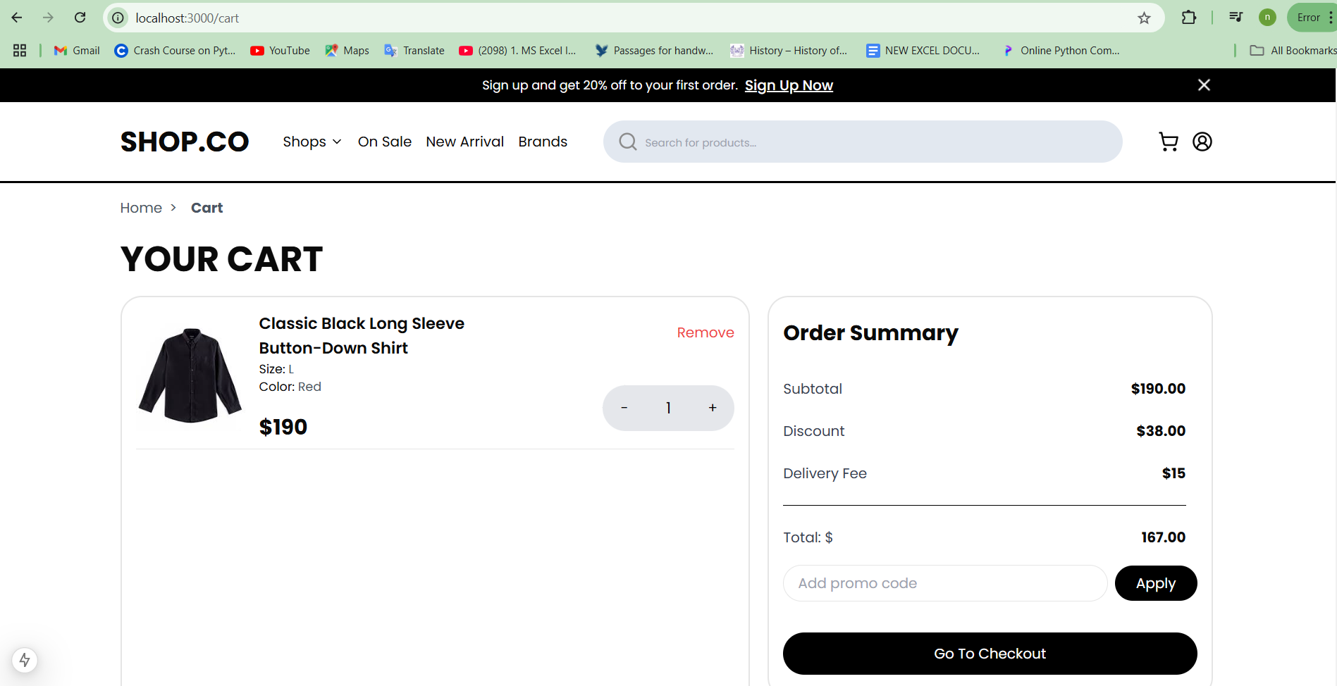

**Summary**

* **The integration between the product page and cart functionality is working as intended.**
* **Dynamic interactions ensure seamless user experience for adding and viewing products in the cart.**